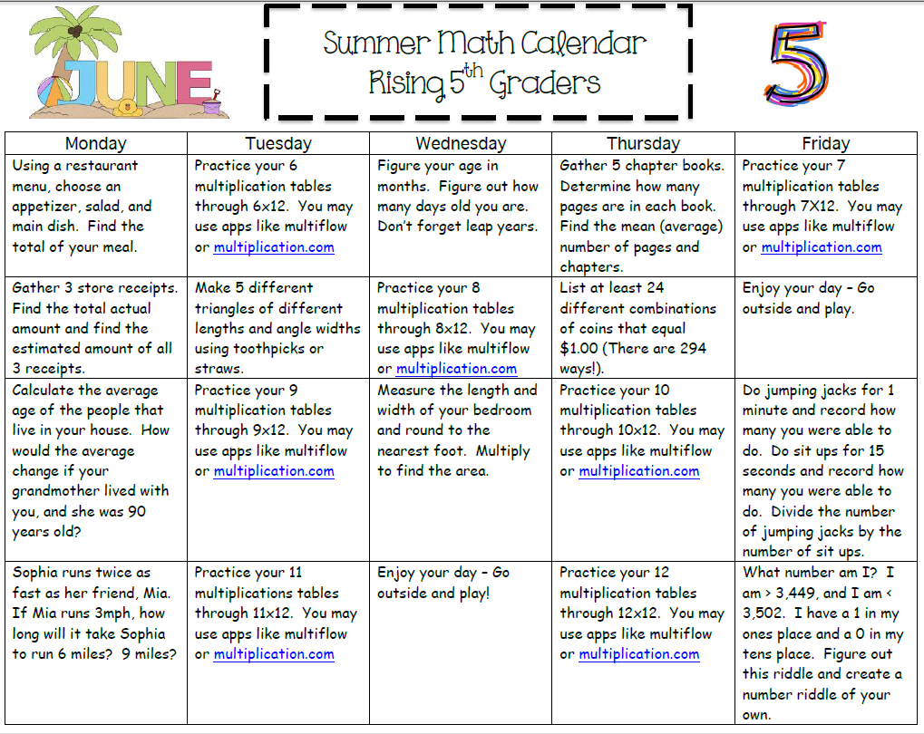

2015 Suggested Fifth Grade Summer Reading Lists

Ages 8-10: http://www.scholastic.com/teachers/sites/default/files/asset/file/src2015_booklist_8-10.pdf

Ages 11-13: http://www.scholastic.com/teachers/sites/default/files/asset/file/src2015_booklist_11-13.pdf

